SAP Demo User Creation

1. ***Logon to SAP as one of the demo users, e.g. S4H_FIN***Credentials can be found here:<https://uipath.atlassian.net/wiki/spaces/FAN/pages/edit/430768758?draftId=430801323&draftShareId=ab7d0e82-f062-4202-9540-5c1294c2b1df&>
2. ***Enter transaction code (TCODE) SU01  
   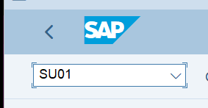***
3. ***Copy an existing user***

Click on “Copy” or use keyboard shortcut “Shift+F5”  
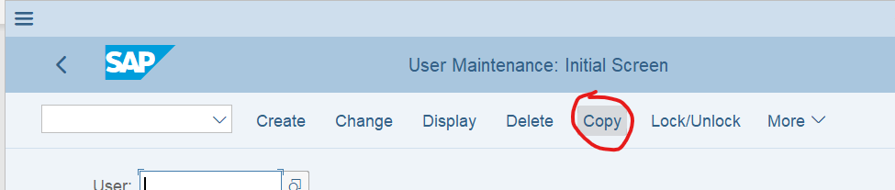

1. ***Enter source user-id and new user-id and click on “Copy”***

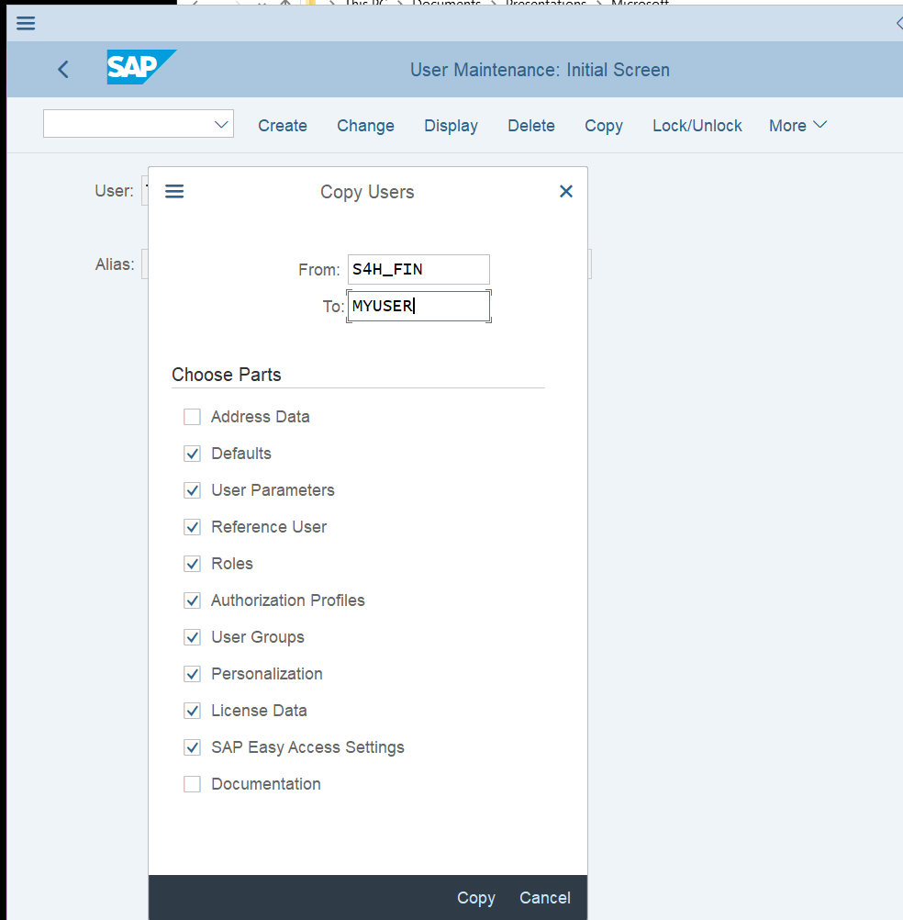

1. ***Add default Company (BUK) for transactions***

Select the tab Parameters and add a new line to the parameters table. Parameter ID = BUK, Value of the default Company = 1010

